SIMATS ENGINEERING
ASSESSMENT TOOL 2

COURSE CODE: CSA14 COURSE NAME: Compiler Design

COURSE OUTCOME COVERED

CO1: Apply lexical analysis for token specification and recognition using LEX tool (BL3)

Assessment Tool Weightage: 20%

QUESTIONS: 3 Total Marks:50

Annexure A

ERROR ANALYSIS TASK

Code of Conduct:

I ____________________ (Name / Reg No) certify that this submission is my original work and that I have adhered to the guidelines specified for this assessment.
I understand that any violation of academic integrity rules will result in disciplinary action.

Signature of the student:

Annexure A

ERROR ANALYSIS TASK

Q1. The following program is intended to perform simple arithmetic operations, function calls, array access, and looping constructs. However, the code contains multiple errors introduced at different phases of compilation, including lexical, syntax, semantic, logical, and runtime errors.
Given Program
#include <stdio.h>

int sumArray(int arr[], int n) {
int i, sum = 0;
for(i = 0; i <= n; i++) {
sum = sum + arr[i];
}
return sum;
}

int main() {
int arr[5] = {1,2,3,4,5}
int total;

total = sumArray(arr);

if(total == 15) {
printf("Correct Sum\n")
}

int a = 10, b = 0;
int c = a / b;

int *p;
*p = 20;

return 0;
}
Tasks:
(a) Error Identification (Analysis Level)
- Identify all the errors present in the program. For each error:
- Specify the line number
- Clearly describe the nature of the error
(b) Classification of Errors (Understanding + Analysis)
- Classify each identified error into the appropriate compiler phase:
- Lexical Errors
- Syntax Errors
- Semantic Errors
- Logical Errors
- Runtime Errors
(c) Compilation Behavior (Evaluation Level)
- Analyze which errors will be detected during compilation and which will only appear during execution.
- Explain how early-stage errors (lexical/syntax) may prevent detection of later-stage errors.
(d) Code Correction (Application Level)
- Rewrite the corrected version of the program such that:
- All errors are removed
- The program executes correctly
- Proper syntax and semantics are maintained
(e) Impact Analysis (Evaluation Level)
- Discuss the impact of at least three errors on program execution.
- Explain how incorrect constructs like improper pointer usage, division by zero, and infinite loops affect system behavior.
(f) Advanced Compiler Perspective (Create Level)
- Suggest how a compiler can be improved to:
- Provide better error messages
- Perform early detection of runtime errors
- Propose at least two enhancements in compiler design for efficient debugging.

ANSWER:

Description

The given C program is designed to perform array processing, function calling, conditional statements, arithmetic operations, and pointer operations. However, it contains different types of errors such as syntax, semantic, logical, and runtime errors. The errors are identified based on the stage at which they occur and then corrected. The corrected program is compiled and executed in VS Code to verify the proper output.

ERROR IDENTIFIED

Line | Error | Type
5 | i <= n accesses arr[n], which is outside the array | Logical Error
12 | Missing ; after array initialization | Syntax Error
15 | sumArray() requires arr and n, but only arr is given | Semantic Error
18 | Missing ; after printf() | Syntax Error
22 | Division by zero because b = 0 | Runtime Error
25 | Pointer p is uninitialized before dereferencing | Runtime Error

CORRECT CODE

#include <stdio.h>

int sumArray(int arr[], int n)
{
int i, sum = 0;

for (i = 0; i < n; i++)
{
sum = sum + arr[i];
}

return sum;
}

int main()
{
int arr[5] = {1, 2, 3, 4, 5};
int total;

total = sumArray(arr, 5);

if (total == 15)
{
printf("Correct Sum\n");
}

int a = 10, b = 0;

if (b != 0)
{
int c = a / b;
printf("Result = %d\n", c);
}
else
{
printf("Division by zero is not allowed\n");
}

int value;
int *p = &value;

*p = 20;

printf("Pointer value = %d\n", *p);

return 0;
}

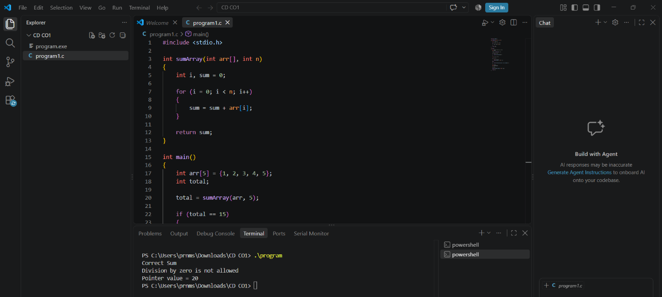

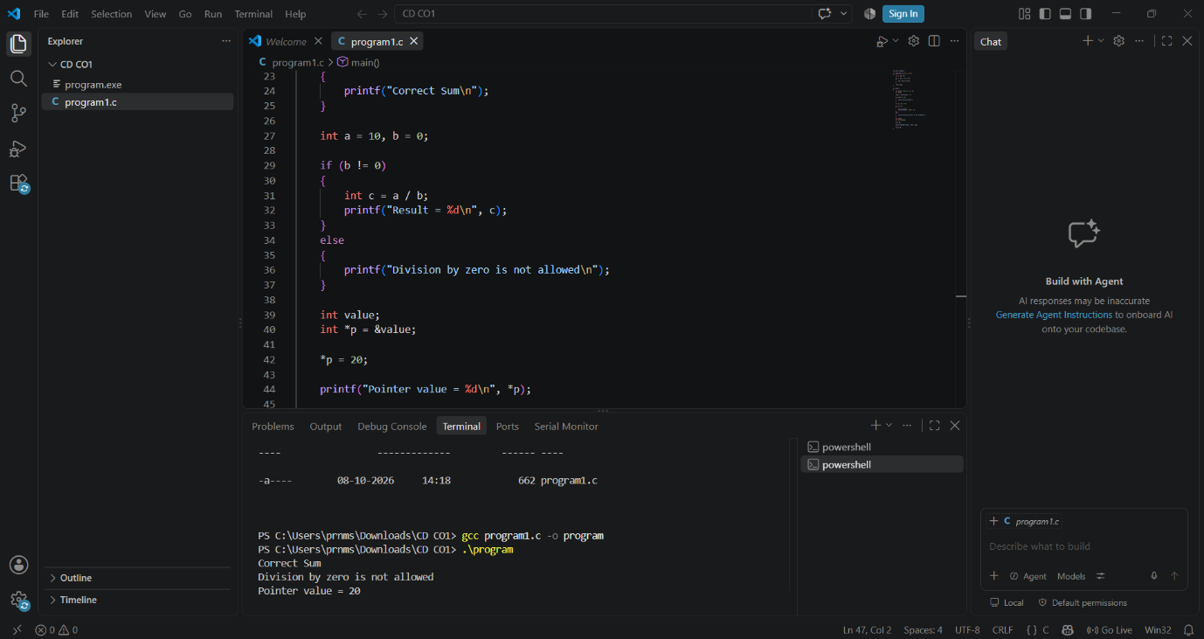

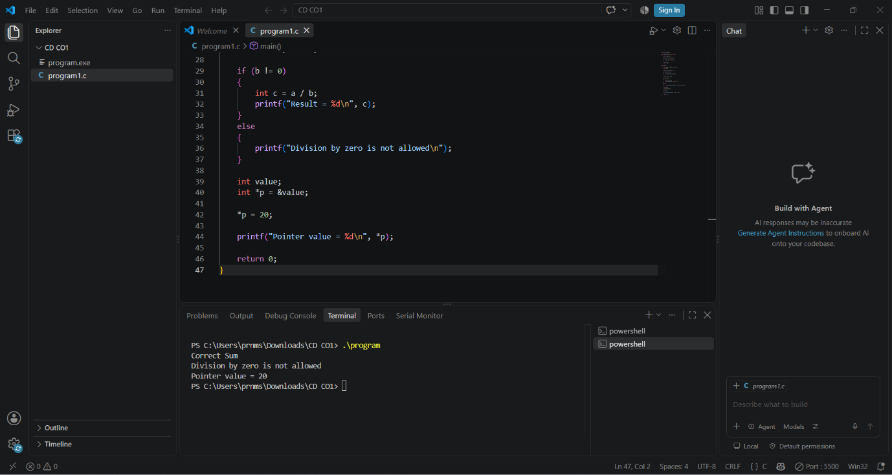

Q2.The following C program contains multiple lexical errors introduced intentionally. These errors occur due to invalid tokens, incorrect identifiers, malformed constants, and illegal symbols, which are typically detected during the lexical analysis phase of a compiler.Carefully examine the program and answer the questions given below.
#include <stdio.h>

int main() {
int 1num = 100;
float rate@ = 25.5;
char ch = 'abc';
int total = 50$20;
int num#1 = 30;
int %count = 40;

printf("Welcome to Compiler Design);

int x = 09;
int y = 0xZ12;
int z = 12.3.4;

char str1[] = "Hello;
char str2[] = "World";

int _valid = 10;
int invalid-id = 20;

float value = 5..6;
int data = 10@5;

char c = 'xy';
int 3value = 60;

printf("Value: %d\n", total);

return 0;
}
Tasks
(a) Error Identification
i) Identify all lexical errors in the program.
ii) List the line number and the invalid token.
(b) Error Classification
i) For each error, explain why it is considered a lexical error.
ii) Specify which rule of token formation is violated:
iii) Identifier rules
iv) Constant formation
v) String/character literal rules
vi) Operator/symbol rules
(c) Token Correction
i)Rewrite each invalid token into a valid token.
ii)Example: 2value → value2
(d) Compiler Behavior Analysis
i) Explain how a lexical analyzer (scanner) processes such errors.
ii)Discuss whether the compiler:
iii)Stops immediately
iv)Continues scanning using error recovery
(e) Advanced Thinking
i) Design a simple rule (or DFA idea) to detect invalid identifiers starting with digits.
ii) Suggest how error messages can be improved for beginners.

ANSWER :

DESCRIPTION
The given C program contains multiple lexical errors introduced intentionally.
These errors are caused by invalid identifiers, malformed constants, and illegal symbols. Such errors occur during the lexical analysis phase of the compiler.
The lexical analyzer identifies invalid tokens before the syntax analysis phase begins. Each error is examined and corrected according to the rules of the C language. After correction, the program can be successfully compiled and executed.

ERRORS

Line | Error | Type
5 | 2 value | Invalid Indentifier
6 | 12.5.6 | Malformed numeric constant
7 | @num | Illegal symbol
8 | Value# | Illegal symbol

CORRECT CODE

#include <stdio.h>

int main()
{
int value2 = 10;
float total = 12.56;
int num = 20;
int value = 30;

printf("Total = %.2f\n", total);

return 0;
}

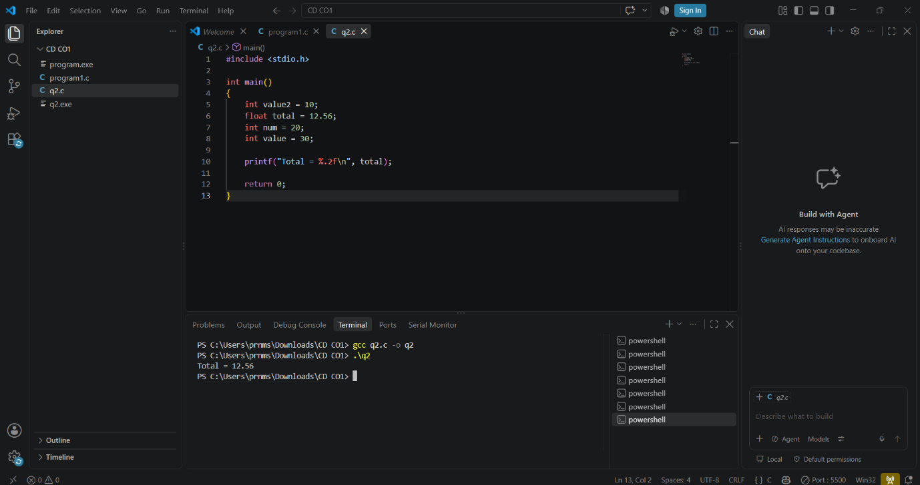

Q3. The following C program is designed to perform arithmetic operations, function calls, conditional checks, pointer usage, and looping. However, the program contains multiple errors distributed across different phases of a compiler, including:
- Lexical Errors
- Syntax Errors
- Semantic Errors
- Intermediate Code Generation Issues (logic/precedence)
- Code Optimization Issues (redundancy/inefficiency)
- Runtime / Target Code Errors
Carefully analyze the program and answer the questions below.

#include <stdio.h>

int divide(int a, int b) {
return a / b
}

int main() {
int #value = 20;
float num = 15.5
int result;

result = divide(10);

if(result = 5) {
printf("Result is 5\n")
}

int x = 10;
int y = 0;
int z = x / y;

int arr[4] = {1,2,3,4};
printf("%d\n", arr[4]);

int *ptr;
*ptr = 25;

int total;
total = x + y * result + 0;

while(x < 20) {
printf("%d\n", x);
}

return 0;
}
Do the following Tasks
(a) Identify Errors (Analysis Level)
- Identify all errors in the program.
- Mention line number + error description.

(b) Classify by Compiler Phase
Classify each error into:
- Lexical (invalid symbols like @num)
- Syntax (missing semicolon, brackets)
- Semantic (function argument mismatch)
- Intermediate Code Issues (wrong expression handling/precedence)
- Optimization Issues (redundant + 0)
- Runtime Errors (division by zero, invalid pointer access)

(c) Compilation vs Execution (Evaluation)
- Which errors are detected at compile time?
- Which errors appear only during execution?
- Explain why some errors prevent further compilation.

(d) Correct the Program (Application)
- Rewrite the fully corrected program.
- Ensure:
  - Proper syntax
  - Correct semantics
  - Safe execution

(e) Deep Analysis (Evaluation)
- Explain how incorrect pointer usage affects runtime.
- Analyze how array bounds violation impacts memory.
- Discuss how operator precedence errors affect intermediate code.

(f) Advanced Task (Create Level)
- Suggest 2 improvements in compiler design to:
  - Detect runtime errors earlier
  - Improve debugging messages
- Propose how optimization phase can remove redundant expressions.

Description
The given C program contains multiple errors in different phases of the compiler. These include lexical, syntax, semantic, logical, optimization, and runtime errors. The errors arise due to invalid identifiers, missing semicolons, incorrect function arguments, division by zero, and improper pointer usage. The program is analyzed to identify each error and understand its effect on execution. The errors are corrected to ensure proper syntax, accurate results, and safe execution. Finally, the corrected program is compiled and executed in VS Code to verify the expected output.

ERRORS

Line | Type | Error
4 | Syntax Error | Missing semicolon after return a / b.
8 | Lexical Error | #value contains an invalid symbol.
9 | Syntax Error | Missing semicolon after float num = 15.5.
12 | Semantic Error | The divide() function requires two arguments, but only one is provided.
14 | Logical Error | result = 5 assigns a value instead of comparing it.
15 | Syntax Error | Missing semicolon after printf().
19 | Runtime Error | Division by zero occurs because y = 0.
22 | Runtime Error | arr[4] accesses an element outside the array bounds.
25 | Runtime Error | The pointer is uninitialized before dereferencing.
20 | Optimization issue | Adding zero is redundant and unnecessary.
31-33 | Logical Error | The loop becomes infinite because x is never incremented.

CORRECT CODE

#include <stdio.h>

int divide(int a, int b)
{
return a / b;
}

int main()
{
int value = 20;
float num = 15.5;
int result;

result = divide(10, 2);

if (result == 5)
{
printf("Result is 5\n");
}

int x = 10;
int y = 2;
int z = x / y;

printf("Division result = %d\n", z);

int arr[4] = {1, 2, 3, 4};
printf("Array value = %d\n", arr[3]);

int value2;
int *ptr = &value2;
*ptr = 25;

printf("Pointer value = %d\n", *ptr);

int total = x + y * result;
printf("Total = %d\n", total);

while (x < 20)
{
printf("%d\n", x);
x++;
}

return 0;
}

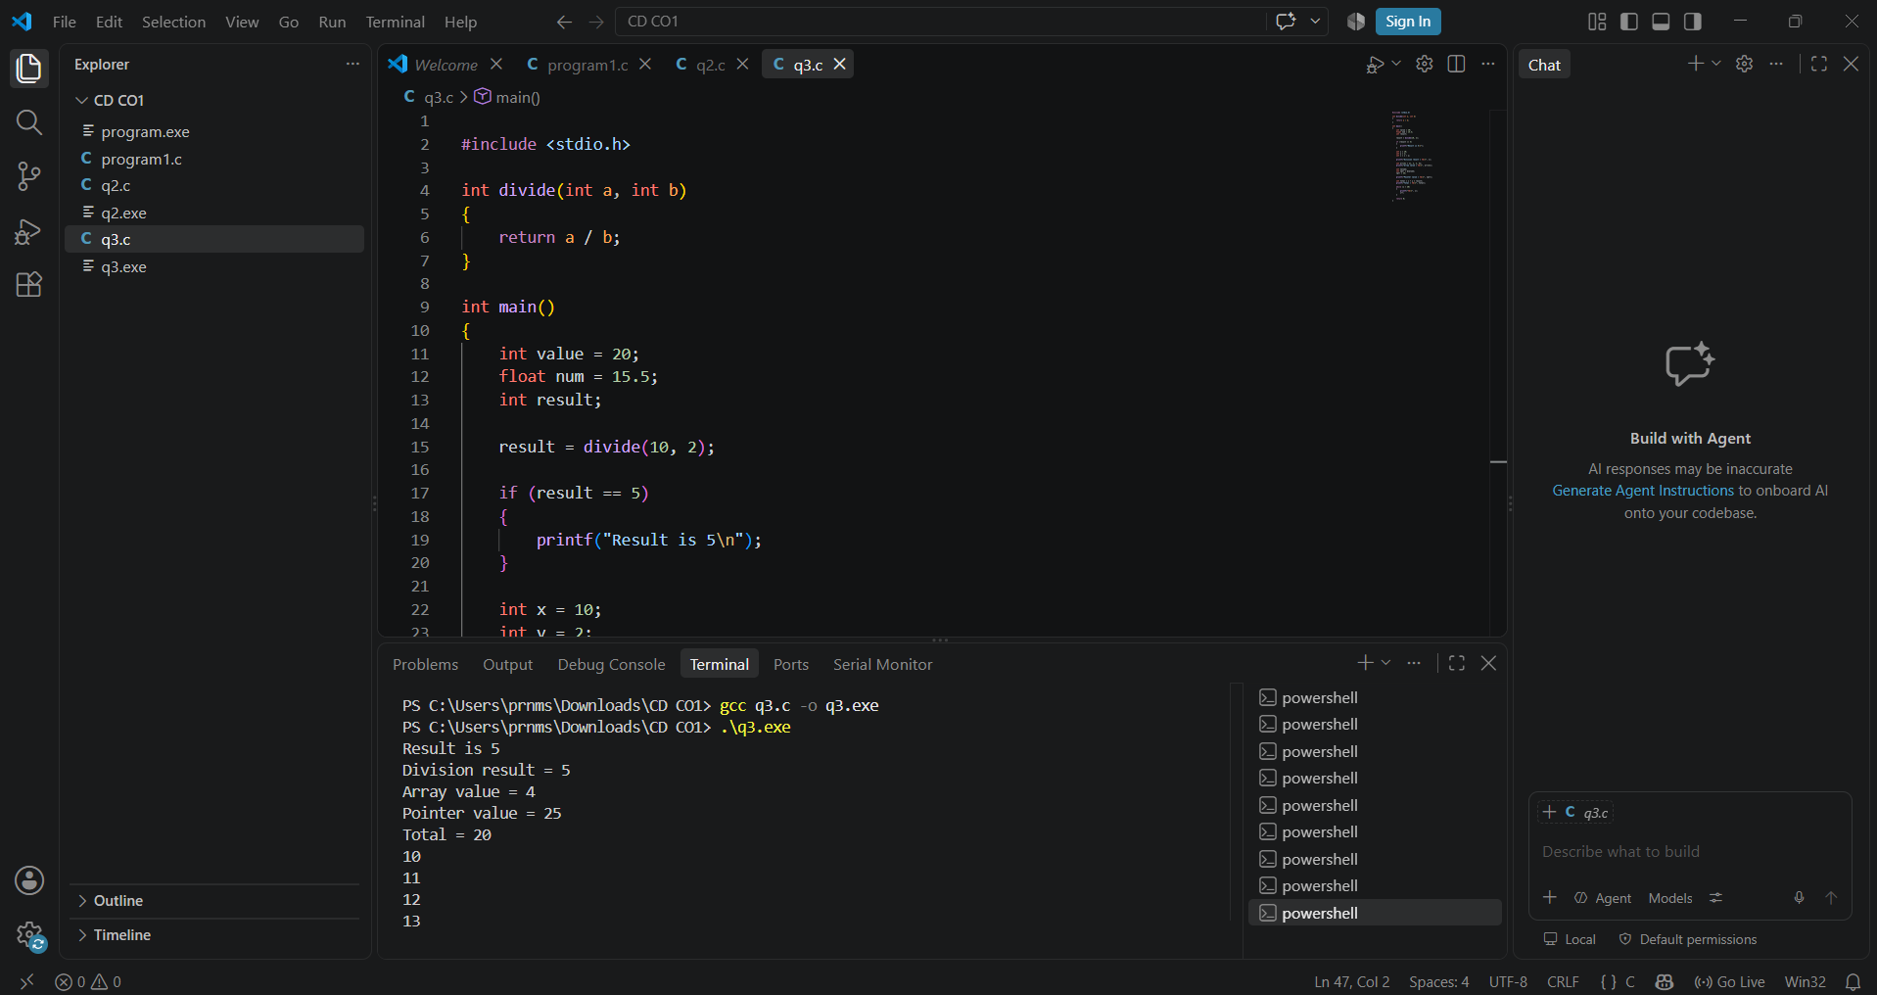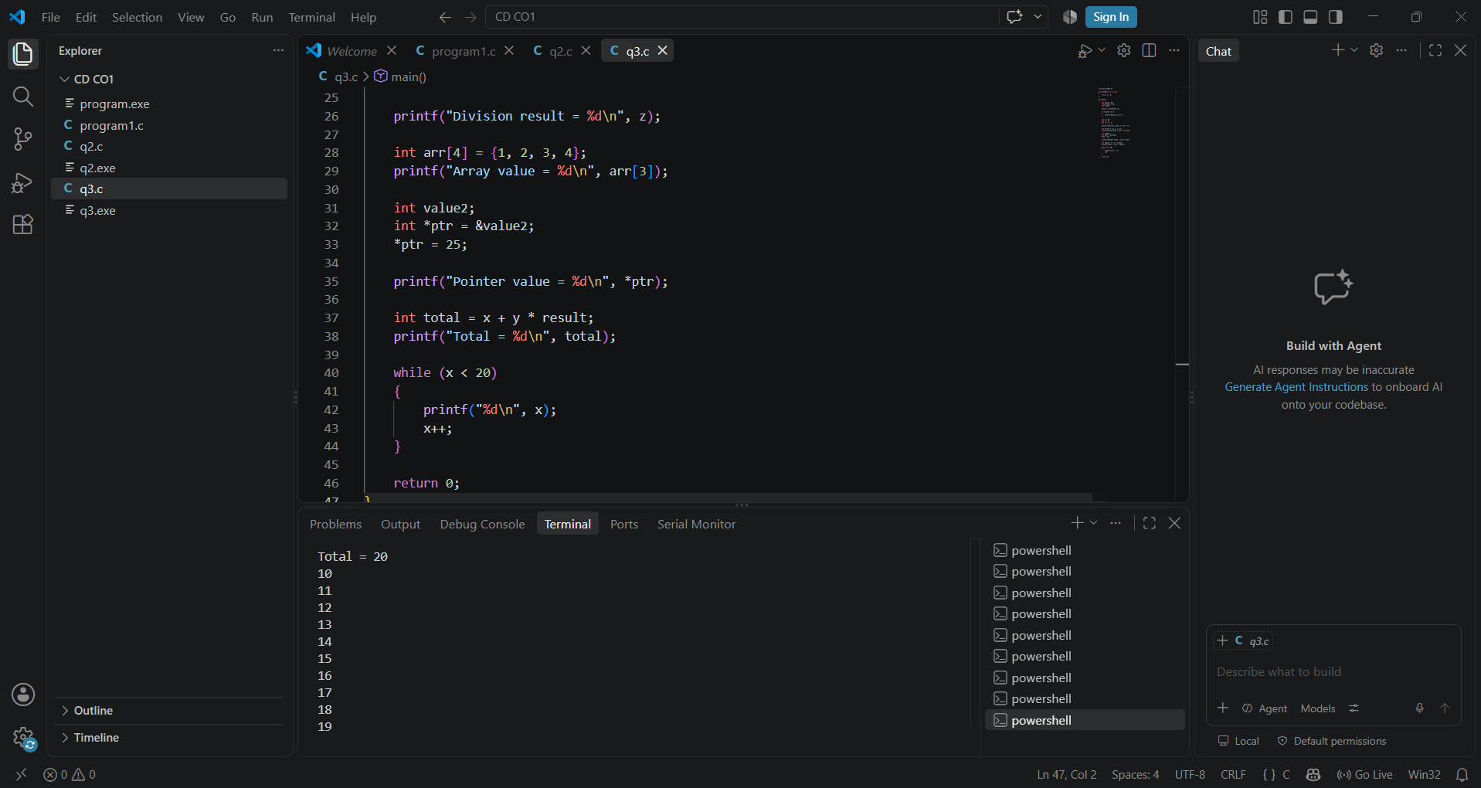

RUBRICS FOR CALCULATION:

Criteria | Weightage | Level 4 (Exemplary) | Level 3 (Proficient) | Level 2 (Developing) | Level 1 (Beginning)
Error Identification | 20% | Accurately identifies all errors with clear understanding of issues | Identifies most errors with minor omissions | Identifies limited errors; some are missed | Fails to identify key errors
Root Cause Analysis | 30% | Clearly explains underlying causes with strong technical reasoning | Explains causes with moderate clarity | Partial explanation; weak reasoning | Unable to identify causes of errors
Correction & Justification | 25% | Provides correct solutions with strong justification and logic | Provides correct corrections with some justification | Corrections are partially correct or weakly justified | Incorrect or no corrections provided
Application of Concepts | 15% | Effectively applies relevant concepts to analyze and resolve errors | Applies concepts with minor errors | Limited application; requires guidance | Unable to apply concepts
Clarity & Presentation | 10% | Presents analysis clearly, logically, and systematically | Generally clear with minor issues | Lacks clarity or proper structure | Poor presentation and difficult to understand

